Project Report

Enforcing Mandatory Fields Using UI Policies and Migrating Changes with Update Sets
Platform: ServiceNow

1️⃣ Introduction & Project Overview

📖 Definition
This project focuses on enforcing mandatory fields dynamically using UI Policies in ServiceNow and migrating those configurations safely across instances using Update Sets.
The goal is to:
- Improve data accuracy
- Prevent incomplete record submissions
- Ensure structured deployment from Development → Test → Production

📦 Project Overview Box
Field | Details
Project Title | Enforcing Mandatory Fields Using UI Policies and Migrating Changes with Update Sets
Platform | ServiceNow
Module | UI Policies & Update Sets
Objective | Enforce mandatory fields dynamically and migrate changes securely
Scope | Incident Table
Instances | Dev, Test, Production
Outcome | Improved data quality & structured deployment

2️⃣ Business Requirement

📖 Definition
The business requires that certain fields must be mandatory when an Incident is moved to Resolved state to ensure proper closure documentation.
This improves:
- Reporting accuracy
- Audit compliance
- Knowledge base generation
- Root cause tracking

📦 Business Requirement Box
Field | Description
Requirement ID | BR-001
Table | Incident
Condition | State = Resolved
Mandatory Fields | Resolution Code, Resolution Notes
Justification | Prevent incomplete ticket closure
Priority | High

3️⃣ UI Policy Configuration

📖 Definition
A UI Policy is configured to make specific fields mandatory when the Incident state changes to Resolved.

📸 UI Policy Configuration Screenshot
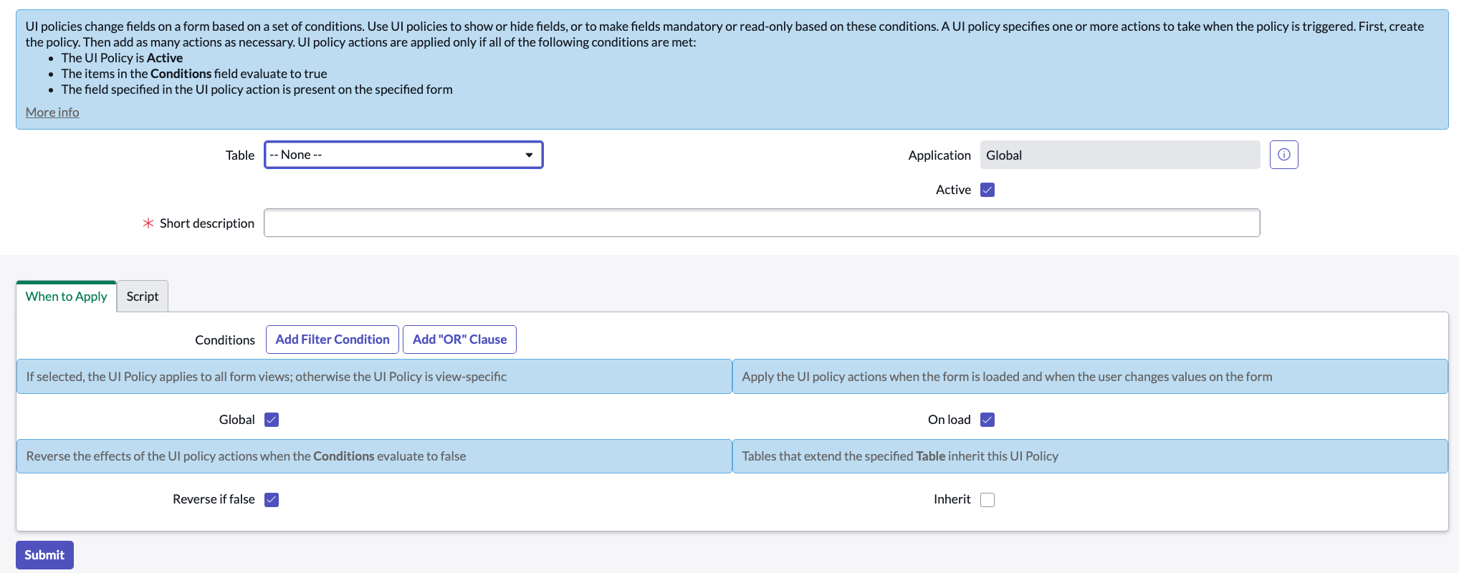
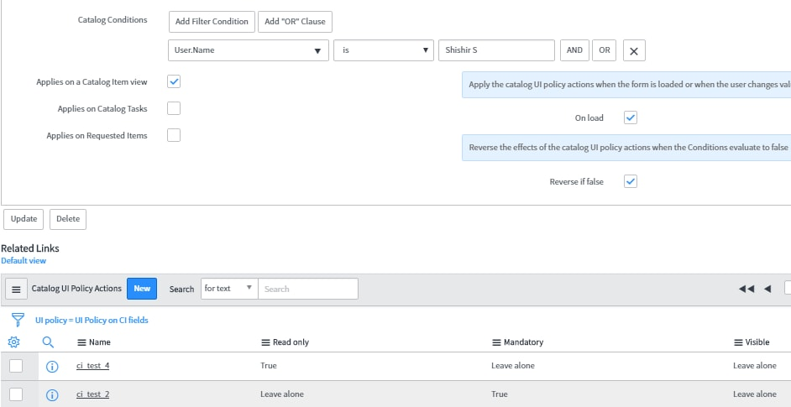
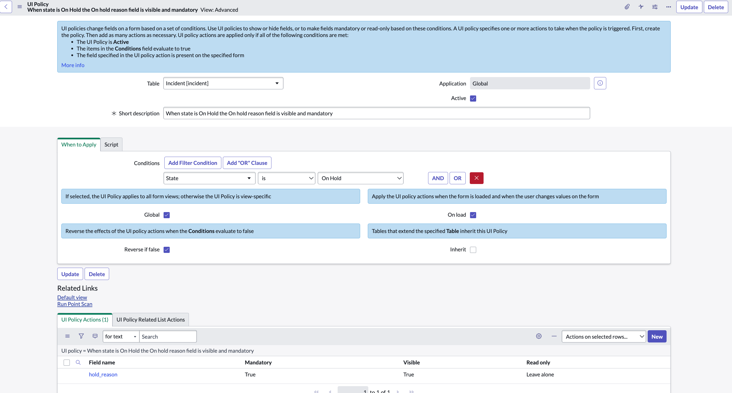
4

📦 UI Policy Configuration Box
Field | Value
UI Policy Name | Enforce Mandatory Fields on Resolution
Table | Incident
Condition | State = Resolved
On Load | True
Reverse If False | True
Description | Makes resolution fields mandatory before closure

4️⃣ UI Policy Actions

📖 Definition
UI Policy Actions define how specific fields behave when the UI Policy condition is met.
Fields can be set to:
- Mandatory
- Visible
- Read-only

📸 UI Policy Action Screenshot
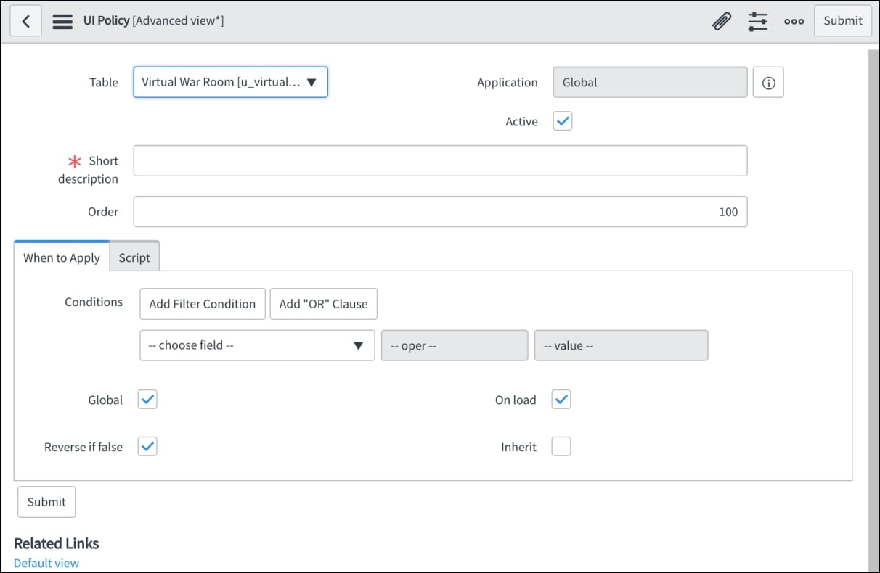
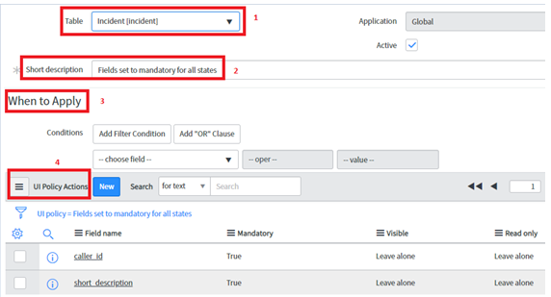
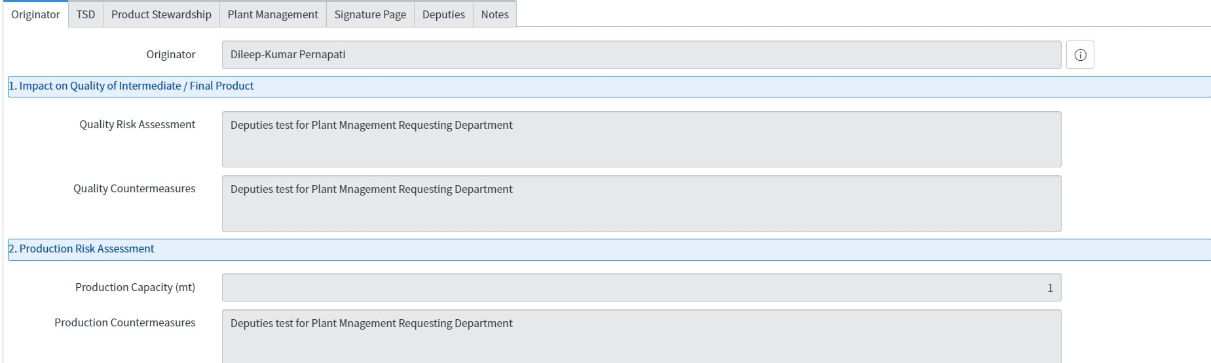
4

📦 UI Policy Action Box
Field Name | Mandatory | Visible | Read-Only
Resolution Code | True | True | False
Resolution Notes | True | True | False
Close Notes | True | True | False

5️⃣ Testing & Validation

📖 Definition
Testing ensures that:
- Fields become mandatory when State = Resolved
- Fields revert when condition is false
- Users cannot close the ticket without required data

📸 Testing Scenario Screenshot
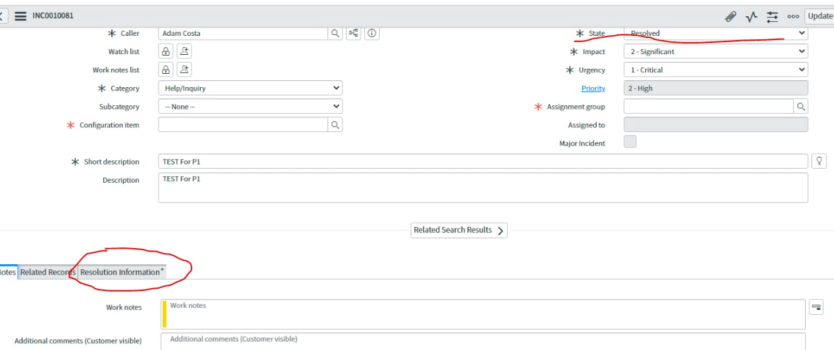
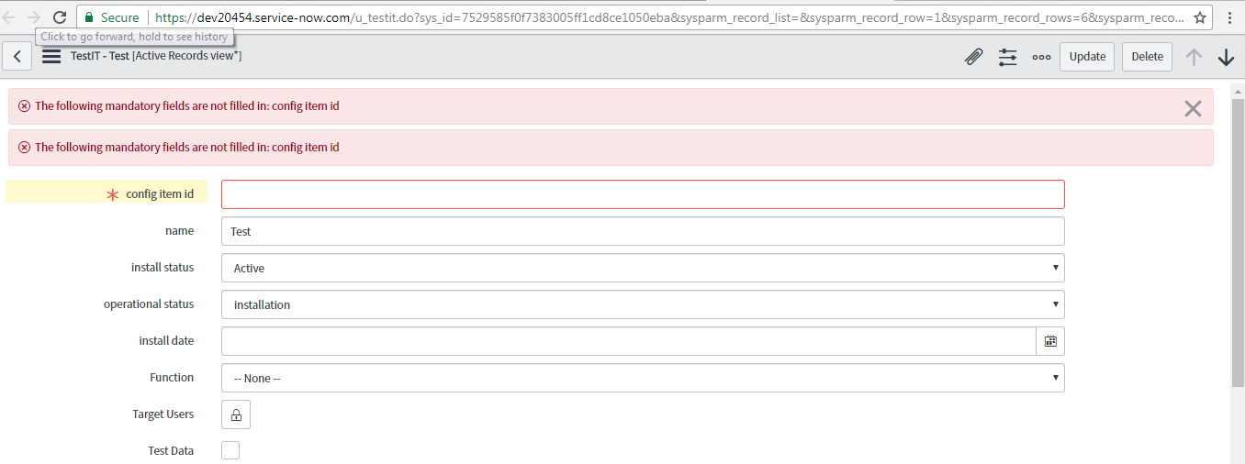
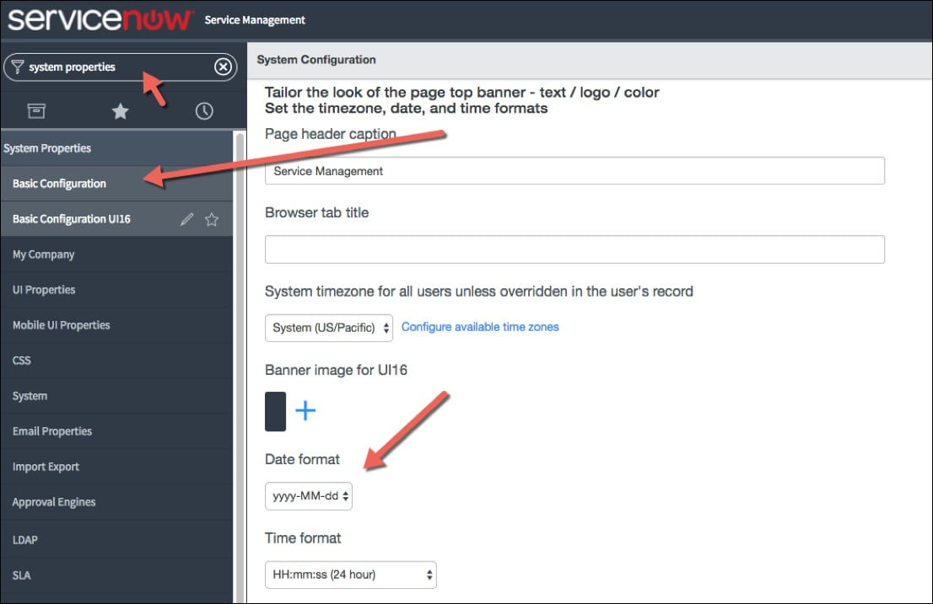
4

📦 Testing & Validation Box
Test Case ID | Scenario | Expected Result | Status
TC-01 | Change state to Resolved | Fields become mandatory | Pass
TC-02 | Remove required field | Error message appears | Pass
TC-03 | Revert state | Fields no longer mandatory | Pass
Validated By: __________
Test Date: __________

6️⃣ Update Set Migration

📖 Definition
Update Sets capture configuration changes and allow migration between instances.
Steps:
- Create Update Set
- Capture changes
- Complete Update Set
- Export XML
- Import to Target Instance
- Preview & Resolve Conflicts
- Commit

📸 Update Set Screenshot
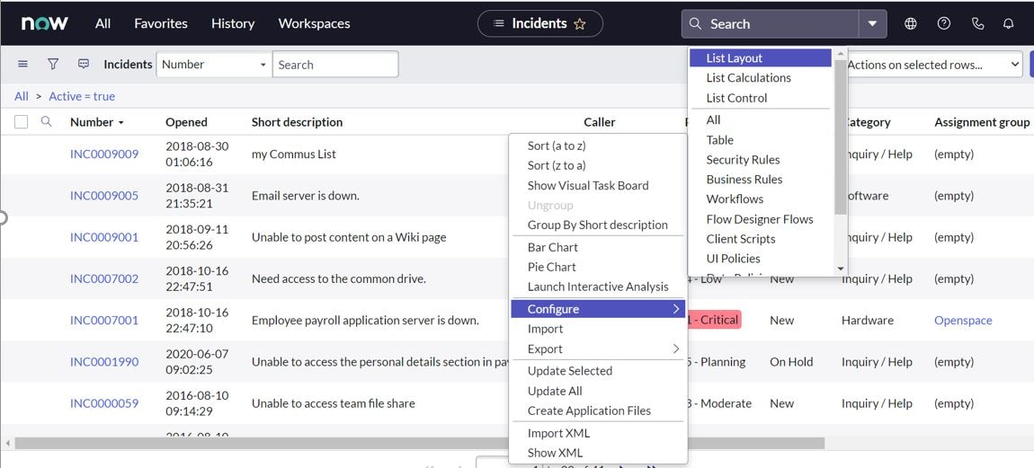

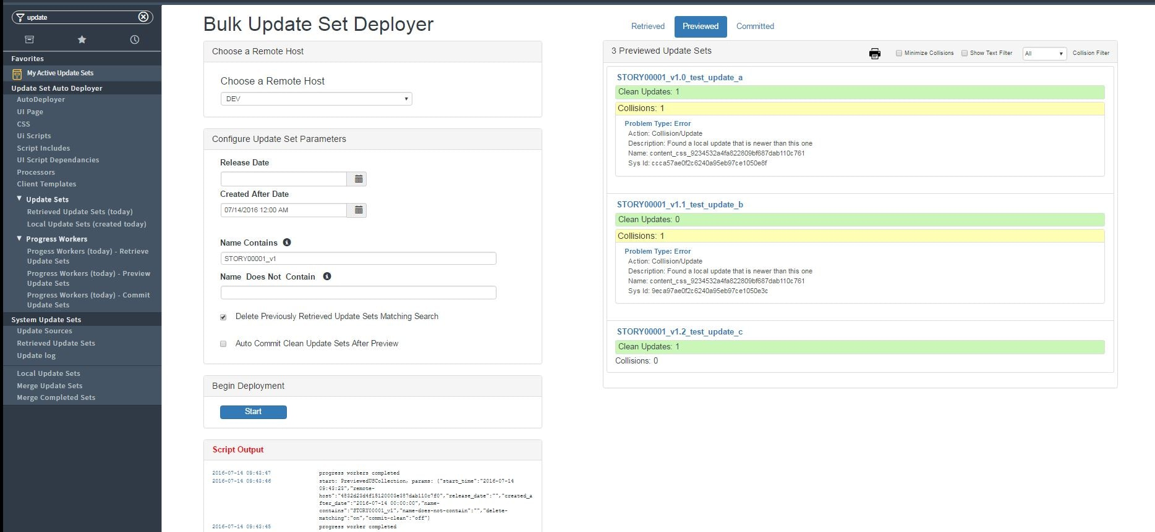
4

📦 Update Set Details Box
Field | Value
Update Set Name | Mandatory Fields Enforcement v1
Source | Development
Target | Test / Production
Components | UI Policy, UI Policy Actions
Review Status | Approved
Backout Plan | Revert to previous Update Set

7️⃣ Risk & Governance

📖 Definition
Proper governance ensures safe deployment and prevents production disruption.

📦 Risk Management Box
Risk ID | Description | Impact | Mitigation
R-01 | Blocking ticket closure | Medium | Test thoroughly
R-02 | Update Set conflict | High | Preview before commit
R-03 | Production error | High | Maintain rollback plan

